EUROPEAN CLUBS 2018
ACCOMMODATION GUIDE

The participating teams are required to send Accommodation Form by mail following address;

Contact Person: Mr. MUSTAFA NESİMİ
e-mail: mustafa@niraturizm.com
Phone Number: +90 555 962 94 72
NIRA TURIZM ORGANISATION COMPANY

WOW Istanbul Hotels & Convention Center
Adresse : Yeşilköy Mahallesi Atatürk Cad. 34149 No:15-17-19 Bakırköy İstanbul TURKIYE
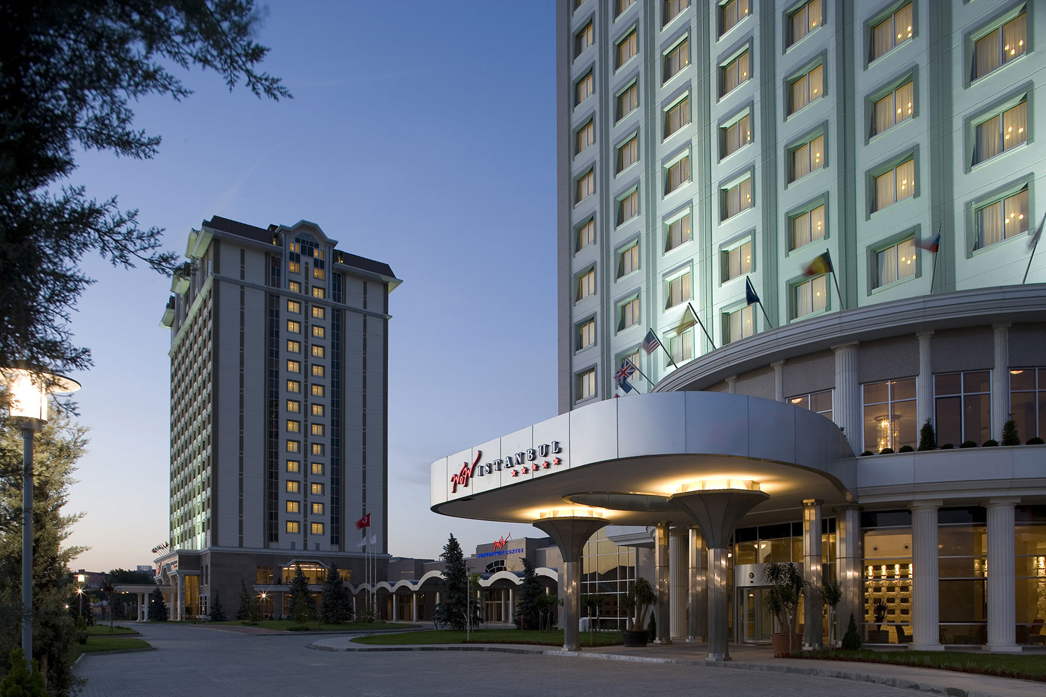
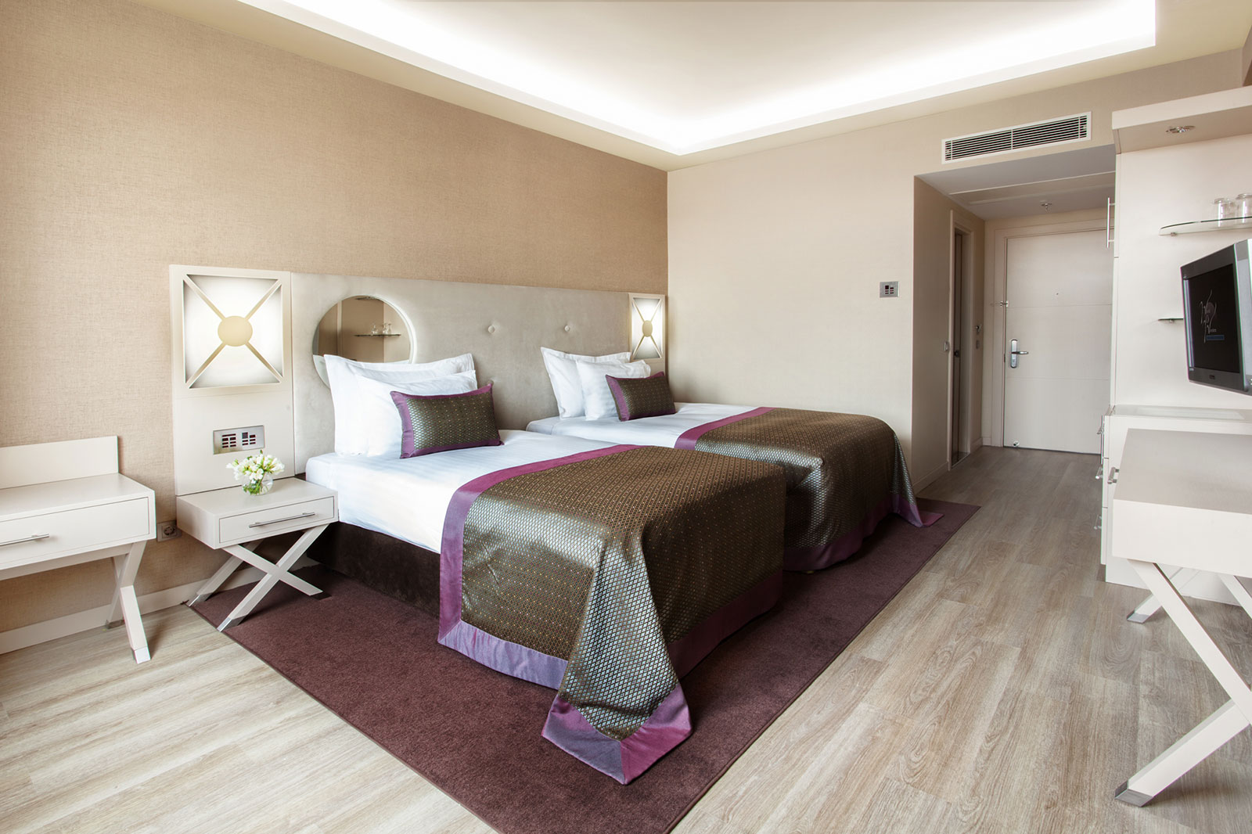
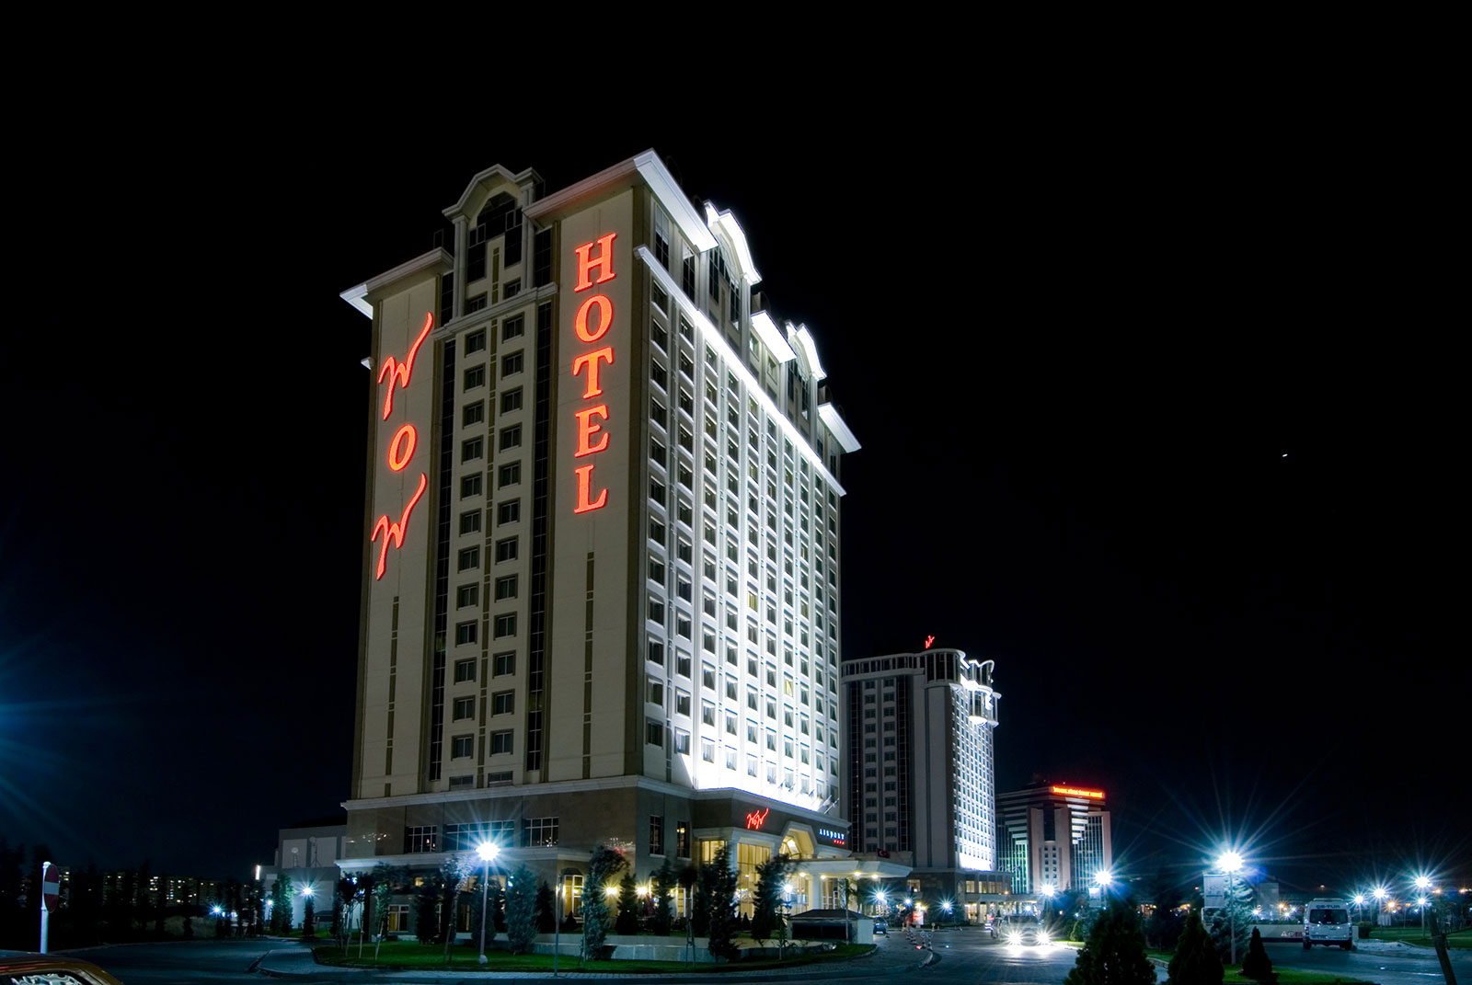

4 * STAR HOTEL
Single Room ( Half Board ) 105.00 EURO (Per Person, Per Night)
Twin Room (Half Board) 70.00 EURO (Per Person, Per Night)
5 * STAR HOTEL
Single Room ( Half Board ) 115.00 EURO (Per Person, Per Night)
Twin Room (Half Board) 75.00 EURO (Per Person, Per Night)
*** soft drink and water will be served free / extra lunch is 15 € ***

ACCOUNT DETAILS
Account Holder : HUSEYIN YALCIN
Swift Code : TGBATRIS
Bank Name : GARANTI BANK
Branch Name : YENI SANAYI
Branch Code : 420
IBAN No : TR14 0006 2000 4200 0009 0906 64

